Project Design Phase-I Solution Architecture

|  |  |
| --- | --- |
| Date | 10 Nov 2022 |
| Team ID | PNT2022TMID29189 |
| Project Name | Project -Real-Time Communication System Powered by AI for Specially Abled |
| Maximum Marks | 4 Marks |

Solution Architecture:

* Solution architecture is a complex process — with many sub-processes — that bridges the gap between business problems and technology solutions.
* Technology used are Python, Jupyter ,Numpy ,OpenCv ,Keras , Tensorflow , GTTS.
* Methodology - We start by collecting key points from mediapipe holistic and collect a bunch of data from keypoints i.e., our hands, on our body and on our face and save data in the form of numpy arrays. We can vary the number of sequences according to our need but each sequence will have 30 frames
* We then build a LSTM model and train with our stored data which helps us to detect action with a number of frames.
* The number of epochs for the model is determined by us, if we increase the number of epochs the accuracy increases but time taken to run the model also increases and overfitting of model can happen, for gesture recognition
* Once training is done, we can use this model for real time hand gesture detection and simultaneously convert the gesture to speech or text using OpenCV.

Solution Architecture Diagram:

Cloud Contacting Service

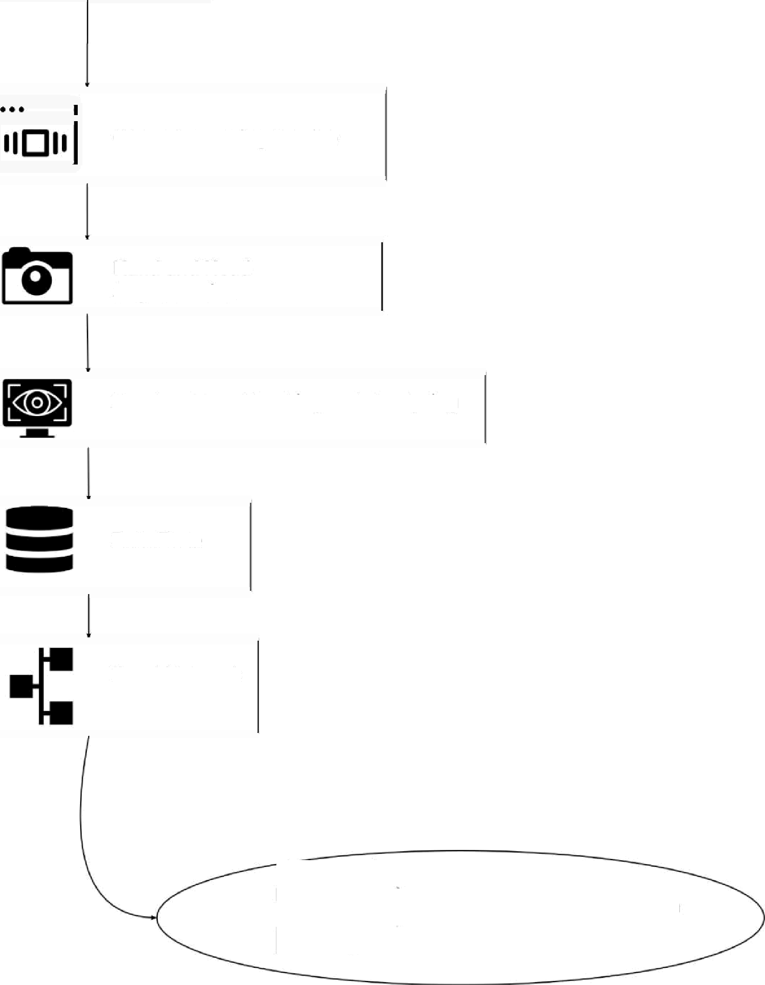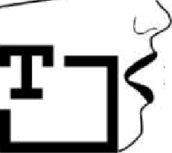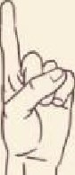

x

“

-

*”

Hand and Head Segmentation

Hand and head tracking and Analysing

Data Base

Nural Netwerk

Voice Corresponding To Sign